**Chapter10: Arrays**

-Type array_name[array_size]

-To access element

-Arrays are sequences of objects of the _ same type

-First element has index and last element has index # element - 1

-Can declare with initialization: type array_name [element]

**Chapter11: Pointers**

- type *pointer_name

- Hold another variables

-&x //returns the address of variable x

-*p //returns the value at the address p

-p = &x; //assigns p the address of variable x

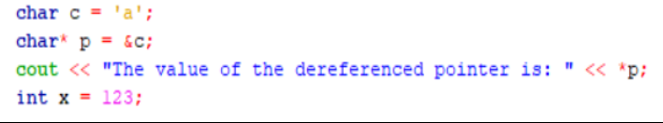

Output => a

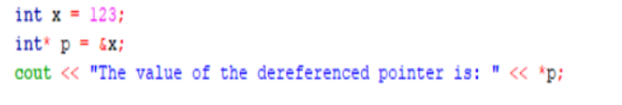

Output => 123

**Chapter12: References**

- type &ref_name

- An alias to an existing variable in memory.

- reference have to be initialized at declaration

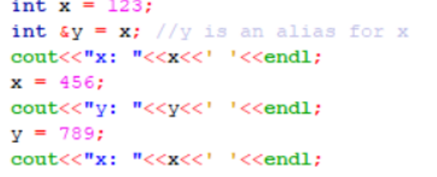

Output => x:123 y:456 z:789

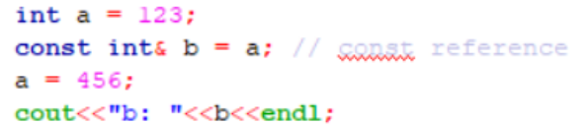

Output => b:456

**Chapter 13:Strings**

- Include in C++ standard library

- Create string s: std::string s = text

- Add two strings new_string = string_1 + string_2

- Compare string: ==

- Input string: std::cin or std::getline

- Pointer to string: .c_str() member function

- Substring:s.substr(starting_position, length)



-Output => Hello world!

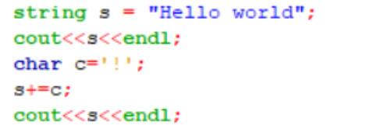

-Output => Hello world

Hello world!

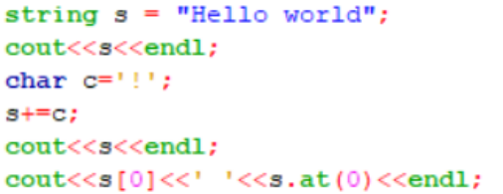

-Output => Hello world

Hello world !

H H

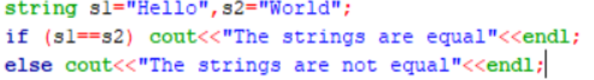

-Output => The strings are not equal

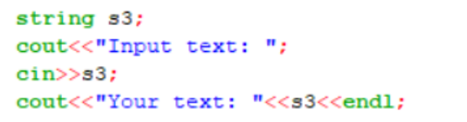

- Output => Input text :Abc

Your text: Abc

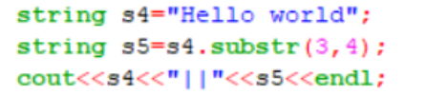

-Output => Hello world|| lo w

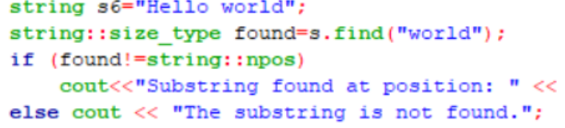

-Output => Substring at postiton

**Chapter 14: Automatic type deduction**

- Deduce type of object automatically

- Syntax: auto x = 123; //or “hello”, or 123.45,…

- Use when deduce some the type ourselves.